Week6_Styling React Components

(cohorts-dashboard)

Objective: To style a React component using both CSS Modules and conditional inline styles

Phase 1: Setting Up Your Development Environment
Step 1: Install Node.js and npm
- Explanation: Node.js is a JavaScript runtime that lets you run JavaScript on your computer. npm is the package manager for Node.js, used to install and manage project dependencies like React.
- Action:
- Open a web browser and navigate to the official Node.js download page: https://nodejs.org/en/download/
Step 2: Install Visual Studio Code
- Explanation: Visual Studio Code (VS Code) is a free, powerful code editor that is highly recommended for React development.
- Action:
- Go to the official VS Code website: https://code.visualstudio.com/
- Download and run the installer for your operating system.
Step 3: Install create-react-app
- Open your command prompt (on Windows) or terminal (on macOS or Linux).
- Type the following command:
npm install -g create-react-app
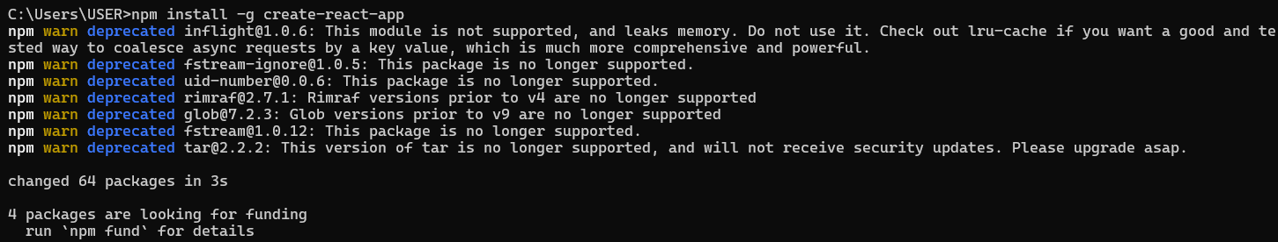

Phase 2: Creating and Running the React Application
Step 4: Create the React Application
- In your command prompt or terminal, navigate to the directory where you want to store your project (e.g., your Desktop or a development folder).
- Type the following command and press Enter. This may take a few minutes to complete.
create-react-app cohorts-dashboard

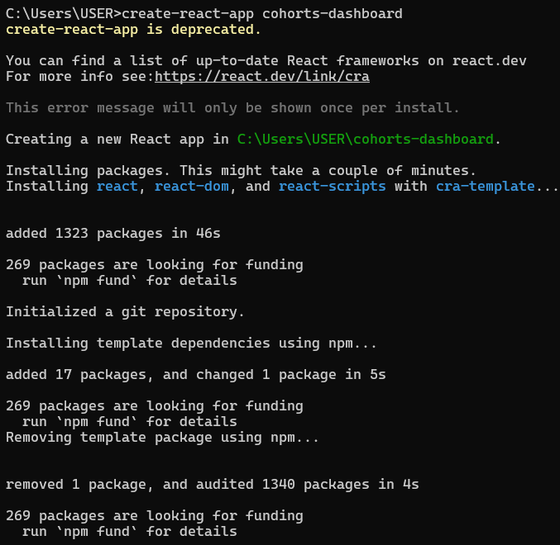
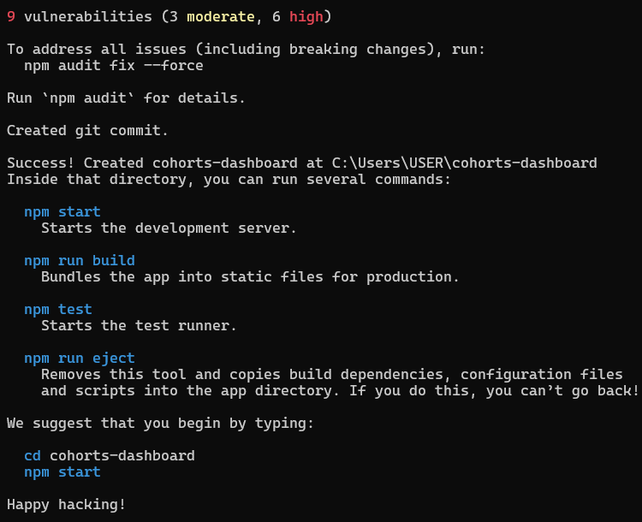

Step 5: Navigate into Your New Project Folder
- You must be inside the project folder to run commands related to this specific application.
- Once the command from Step 4 is finished, type the following command to move into the newly created directory:
cd cohorts-dashboard
Step 6: Open the Project in Visual Studio Code
- This command opens the entire project folder in VS Code, allowing you to easily browse and edit the project files.
- While in the myfirstreact folder in your command prompt or terminal,
- Type the commands:
npm install
code .
Note: The . tells VS Code to open the current directory.
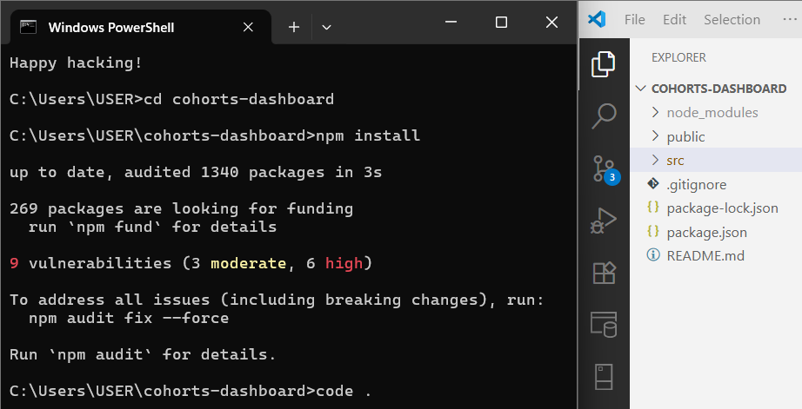
Step 7: Add Styles to CohortDetails.js
- Open the CohortDetails.js file and paste this code
import React from 'react';
import styles from './CohortDetails.module.css'; // Import the CSS module
const cohortData = [
{ id: 1, name: 'INTADMF10 - .NET FSD', startedOn: '22-Feb-2022', status: 'Scheduled', coach: 'Aathma', trainer: 'Jojo Jose' },
{ id: 2, name: 'ADM21JF014 - Java FSD', startedOn: '10-Sep-2021', status: 'Ongoing', coach: 'Apoorv', trainer: 'Elisa Smith' },
{ id: 3, name: 'CDBJF21025 - Java FSD', startedOn: '24-Dec-2021', status: 'Ongoing', coach: 'Aathma', trainer: 'John Doe' }];
const CohortDetails = () => {
return (
<div>
<h1>Cohorts Details</h1>
<div className="container">
{cohortData.map(cohort => (
// Apply the .box class from the CSS module
<div key={cohort.id} className={styles.box}>
{/* Apply conditional inline style for color */}
<h3 style={{ color: cohort.status === 'Ongoing' ? 'green' : 'blue' }}>
{cohort.name}
</h3>
<dl>
<dt>Started On</dt>
<dd>{cohort.startedOn}</dd>
<dt>Current Status</dt>
<dd>{cohort.status}</dd>
<dt>Coach</dt>
<dd>{cohort.coach}</dd>
<dt>Trainer</dt>
<dd>{cohort.trainer}</dd>
</dl>
</div>
))}
</div>
</div>
);
};
export default CohortDetails;
Step 8: Add Component Logic to CohortDetails.module.css
- Open the CohortDetails.module.css file and paste this code.
.box {
width: 300px;
display: inline-block;
margin: 10px;
padding: 10px 20px;
border: 1px solid black;
border-radius: 10px;
box-shadow: 0 2px 5px rgba(0,0,0,0.1); /* for a nicer look */
vertical-align: top; /* Ensures boxes align correctly */
}
/* This is a global tag selector within the module's scope */
:global(dt) {
font-weight: 500;
}
Step 9: Edit the Main App.js File
- Open the App.js file from the src folder.
- Replace all of its content with this code:
import React from 'react';
import CohortDetails from './CohortDetails';
import './App.css';
function App() {
return (
<div className="App">
<CohortDetails />
</div>
);
}
export default App;
Step 10: Run the Application
- Go back to your terminal (it should still be in the blogApp folder).
- Run the start command:
npm start

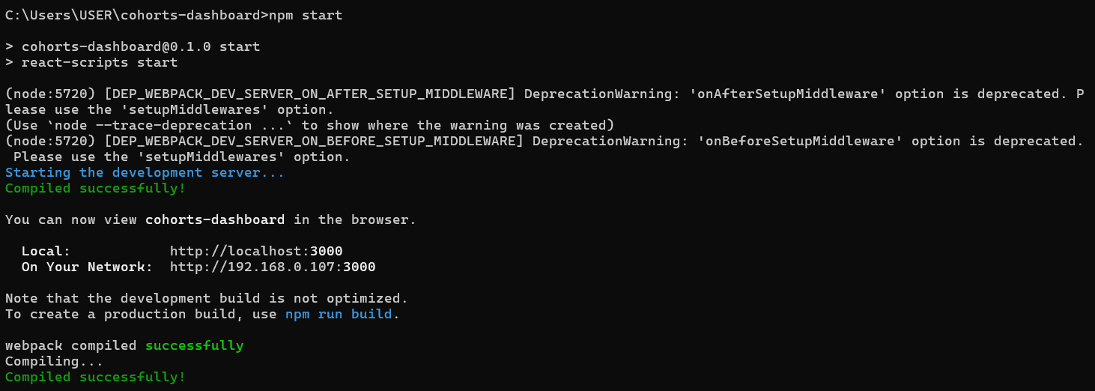
Step 11: View Your Application
- The development server hosts your application on a local port, typically 3000.
Local: http://localhost:3000
On Your Network: http://192.168.0.107:3000
Output:
